**Mobile Application Development Laboratory**

**Course Code 18CSL78 Credits 1.5 Course type LAB CIE Marks : 25 marks Hours/week: L-T-P 0-0-3 SEE Marks 25 marks Total Hours 30 SEE Duration 3 Hours for 50 marks**

**List of experiments**

**1. Develop an application that uses GUI components, Font and Colors.**

**2. Develop an application that uses Layout Managers and event listeners.**

**3. Develop a native calculator application.**

**4. Develop an application that makes use of database.**

**5. Develop an application that makes use of notification.**

**1. Develop an application that uses GUI components, Font and Colors**

## **Aim:**

**To develop a Simple Android Application that uses GUI components, Font and Colors.**

### Creating a New project:

1. **Open Android Studio and then click on File -> New -> New project**
2. **Then type the Application name as “ex.no.1″ and click Next.**
3. **Then select the Minimum SDK as shown below and click Next.**
4. **Then select the Empty Activity and click Next.**
5. **Finally click Finish.**
6. **It will take some time to build and load the project.**
7. **After completion it will look as given below.**

### Designing layout for the Android Application:

1. Click on app -> res -> layout -> activity_main.xml.
2. Now click on Text as shown below.
3. Then delete the code which is there and type the code as given below.

**Activity.xml**

**<?xml version="1.0" encoding="utf-8"?>**

**<LinearLayout xmlns:android="http://schemas.android.com/apk/res/android"**

**android:orientation="vertical"**

**android:layout_width="match_parent"**

**android:layout_height="match_parent">**

**<TextView**

**android:id="@+id/textView"**

**android:layout_width="match_parent"**

**android:layout_height="wrap_content"**

**android:layout_margin="30dp"**

**android:gravity="center"**

**android:text="Hello World!"**

**android:textSize="25sp"**

**android:textStyle="bold" />**

**<Button**

**android:id="@+id/button1"**

**android:layout_width="match_parent"**

**android:layout_height="wrap_content"**

**android:layout_margin="20dp"**

**android:gravity="center"**

**android:text="Change font size"**

**android:textSize="25sp" />**

**<Button**

**android:id="@+id/button2"**

**android:layout_width="match_parent"**

**android:layout_height="wrap_content"**

**android:layout_margin="20dp"**

**android:gravity="center"**

**android:text="Change color"**

**android:textSize="25sp" />**

**</LinearLayout>**

1. Now click on Design and your application will look as given below.
2. So now the designing part is completed.

### Java Coding for the Android Application:

1. Click on app -> java -> com.example.exno1 -> MainActivity.
2. Then delete the code which is there and type the code as given below.

MainActivity.java:

**package com.example.exno1;**

**import android.graphics.Color;**

**import android.support.v7.app.AppCompatActivity;**

**import android.os.Bundle;**

**import android.view.View;**

**import android.widget.Button;**

**import android.widget.TextView;**

**public class MainActivity extends AppCompatActivity**

**{**

**int ch=1;**

**float font=30;**

**@Override**

**protected void onCreate(Bundle savedInstanceState)**

**{**

**super.onCreate(savedInstanceState);**

**setContentView(R.layout.activity_main);**

**final TextView t= (TextView) findViewById(R.id.textView);**

**Button b1= (Button) findViewById(R.id.button1);**

**b1.setOnClickListener(new View.OnClickListener() {**

**@Override**

**public void onClick(View v) {**

**t.setTextSize(font);**

**font = font + 5;**

**if (font == 50)**

**font = 30;**

**}**

**});**

**Button b2= (Button) findViewById(R.id.button2);**

**b2.setOnClickListener(new View.OnClickListener() {**

**@Override**

**public void onClick(View v) {**

**switch (ch) {**

**case 1:**

**t.setTextColor(Color.RED);**

**break;**

**case 2:**

**t.setTextColor(Color.GREEN);**

**break;**

**case 3:**

**t.setTextColor(Color.BLUE);**

**break;**

**case 4:**

**t.setTextColor(Color.CYAN);**

**break;**

**case 5:**

**t.setTextColor(Color.YELLOW);**

**break;**

**case 6:**

**t.setTextColor(Color.MAGENTA);**

**break;**

**}**

**ch++;**

**if (ch == 7)**

**ch = 1;**

**}**

**});**

**}**

**}**

4. So now the Coding part is also completed.

5. Now run the application to see the output.

## Output :

**2. Develop an application that uses Layout Managers and event listeners.**

## Aim :

To develop a Simple Android Application that uses Layout Managers and Event Listeners.

## Procedure:

### Creating a New project:

* Open Android Stdio and then click on File -> New -> New project.
* Then type the Application name as “ex.no.2″ and click Next.
* Then select the Minimum SDK as shown below and click Next.
* Then select the Empty Activity and click Next.
* Finally click Finish.
* It will take some time to build and load the project.

### Creating Second Activity for the Android Application:

* Click on File -> New -> Activity -> Empty Activity.
* Type the Activity Name as SecondActivity and click Finish button.
* Thus Second Activity For the application is created.

### Designing layout for the Android Application:

#### Designing Layout for Main Activity:

* Click on app -> res -> layout -> activity_main.xml.
* Now click on Text as shown below.
* Then delete the code which is there and type the code as given below.

**activity_main.xml**

<?xml version="1.0" encoding="utf-8"?>

<RelativeLayout xmlns:android="http://schemas.android.com/apk/res/android"

xmlns:tools="http://schemas.android.com/tools"

android:layout_width="match_parent"

android:layout_height="match_parent"

tools:context=".MainActivity">

<LinearLayout

android:layout_width="match_parent"

android:layout_height="100dp">

<TextView

android:id="@+id/textView"

android:layout_width="match_parent"

android:layout_height="wrap_content"

android:layout_margin="30dp"

android:text="Details Form"

android:textSize="25sp"

android:gravity="center"/>

</LinearLayout>

<GridLayout

android:id="@+id/gridLayout"

android:layout_width="match_parent"

android:layout_height="match_parent"

android:layout_marginTop="100dp"

android:layout_marginBottom="200dp"

android:columnCount="2"

android:rowCount="3">

<TextView

android:id="@+id/textView1"

android:layout_width="wrap_content"

android:layout_height="wrap_content"

android:layout_margin="10dp"

android:layout_row="0"

android:layout_column="0"

android:text="Name"

android:textSize="20sp"

android:gravity="center"/>

<EditText

android:id="@+id/editText"

android:layout_width="wrap_content"

android:layout_height="wrap_content"

android:layout_margin="10dp"

android:layout_row="0"

android:layout_column="1"

android:ems="10"/>

<TextView

android:id="@+id/textView2"

android:layout_width="wrap_content"

android:layout_height="wrap_content"

android:layout_margin="10dp"

android:layout_row="1"

android:layout_column="0"

android:text="Reg.No"

android:textSize="20sp"

android:gravity="center"/>

<EditText

android:id="@+id/editText2"

android:layout_width="wrap_content"

android:layout_height="wrap_content"

android:layout_margin="10dp"

android:layout_row="1"

android:layout_column="1"

android:inputType="number"

android:ems="10"/>

<TextView

android:id="@+id/textView3"

android:layout_width="wrap_content"

android:layout_height="wrap_content"

android:layout_margin="10dp"

android:layout_row="2"

android:layout_column="0"

android:text="Dept"

android:textSize="20sp"

android:gravity="center"/>

<Spinner

android:id="@+id/spinner"

android:layout_width="wrap_content"

android:layout_height="wrap_content"

android:layout_margin="10dp"

android:layout_row="2"

android:layout_column="1"

android:spinnerMode="dropdown"/>

</GridLayout>

<Button

android:id="@+id/button"

android:layout_width="wrap_content"

android:layout_height="wrap_content"

android:layout_alignParentBottom="true"

android:layout_centerInParent="true"

android:layout_marginBottom="150dp"

android:text="Submit"/>

</RelativeLayout>

* Now click on Design and your activity will look as given below.
* So now the designing part of Main Activity is completed.

#### Designing Layout for Second Activity:

* Click on app -> res -> layout -> activity_second.xml.
* Now click on Text as shown below.
* Then delete the code which is there and type the code as given below.

ActivitySecond.xml

<?xml version="1.0" encoding="utf-8"?>

<LinearLayout xmlns:android="http://schemas.android.com/apk/res/android"

xmlns:tools="http://schemas.android.com/tools"

android:layout_width="match_parent"

android:layout_height="match_parent"

tools:context="com.example.devang.exno2.SecondActivity"

android:orientation="vertical"

android:gravity="center">

<TextView

android:id="@+id/textView1"

android:layout_width="wrap_content"

android:layout_height="wrap_content"

android:layout_margin="20dp"

android:text="New Text"

android:textSize="30sp"/>

<TextView

android:id="@+id/textView2"

android:layout_width="wrap_content"

android:layout_height="wrap_content"

android:layout_margin="20dp"

android:text="New Text"

android:textSize="30sp"/>

<TextView

android:id="@+id/textView3"

android:layout_width="wrap_content"

android:layout_height="wrap_content"

android:layout_margin="20dp"

android:text="New Text"

android:textSize="30sp"/>

</LinearLayout>

* Now click on Design and your activity will look as given below.
* So now the designing part of Second Activity is also completed.

### Java Coding for the Android Application:

#### Java Coidng for Main Activity:

* Click on app -> java -> com.example.exno2 -> MainActivity.
* Then delete the code which is there and type the code as given below.

**MainActivity.java:  
  
package com.example.exno2;**

**import android.content.Intent;**

**import android.support.v7.app.AppCompatActivity;**

**import android.os.Bundle;**

**import android.view.View;**

**import android.widget.ArrayAdapter;**

**import android.widget.Button;**

**import android.widget.EditText;**

**import android.widget.Spinner;**

**public class MainActivity extends AppCompatActivity {**

**//Defining the Views**

**EditText e1,e2;**

**Button bt;**

**Spinner s;**

**//Data for populating in Spinner**

**String [] dept_array={"CSE","ECE","IT","Mech","Civil"};**

**String name,reg,dept;**

**@Override**

**protected void onCreate(Bundle savedInstanceState) {**

**super.onCreate(savedInstanceState);**

**setContentView(R.layout.activity_main);**

**//Referring the Views**

**e1= (EditText) findViewById(R.id.editText);**

**e2= (EditText) findViewById(R.id.editText2);**

**bt= (Button) findViewById(R.id.button);**

**s= (Spinner) findViewById(R.id.spinner);**

**//Creating Adapter for Spinner for adapting the data from array to Spinner**

**ArrayAdapter adapter= new ArrayAdapter(MainActivity.this,android.R.layout.simple_spinner_item,dept_array);**

**s.setAdapter(adapter);**

**//Creating Listener for Button**

**bt.setOnClickListener(new View.OnClickListener() {**

**@Override**

**public void onClick(View v) {**

**//Getting the Values from Views(Edittext & Spinner)**

**name=e1.getText().toString();**

**reg=e2.getText().toString();**

**dept=s.getSelectedItem().toString();**

**//Intent For Navigating to Second Activity**

**Intent i = new Intent(MainActivity.this,SecondActivity.class);**

**//For Passing the Values to Second Activity**

**i.putExtra("name_key", name);**

**i.putExtra("reg_key",reg);**

**i.putExtra("dept_key", dept);**

**startActivity(i);**

**}**

**});**

**}**

**}**

* So now the Coding part of Main Activity is completed.

#### Java Coding for Second Activity:

* Click on app -> java -> com.example.exno2 -> SecondActivity.
* Then delete the code which is there and type the code as given below.

SecondActivity.java:

**package com.example.exno2;**

**import android.content.Intent;**

**import android.support.v7.app.AppCompatActivity;**

**import android.os.Bundle;**

**import android.widget.TextView;**

**public class SecondActivity extends AppCompatActivity {**

**TextView t1,t2,t3;**

**String name,reg,dept;**

**@Override**

**protected void onCreate(Bundle savedInstanceState) {**

**super.onCreate(savedInstanceState);**

**setContentView(R.layout.activity_second);**

**t1= (TextView) findViewById(R.id.textView1);**

**t2= (TextView) findViewById(R.id.textView2);**

**t3= (TextView) findViewById(R.id.textView3);**

**//Getting the Intent**

**Intent i = getIntent();**

**//Getting the Values from First Activity using the Intent received**

**name=i.getStringExtra("name_key");**

**reg=i.getStringExtra("reg_key");**

**dept=i.getStringExtra("dept_key");**

**//Setting the Values to Intent**

**t1.setText(name);**

**t2.setText(reg);**

**t3.setText(dept);**

**}**

**}**

* So now the Coding part of Second Activity is also completed.
* Now run the application to see the output.

**Output :**

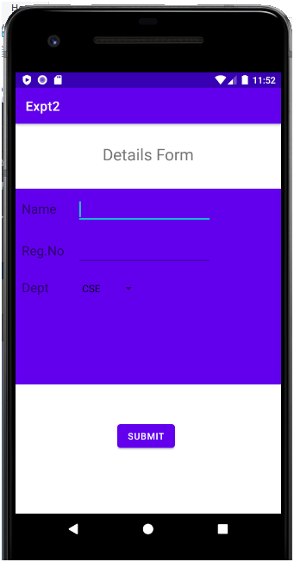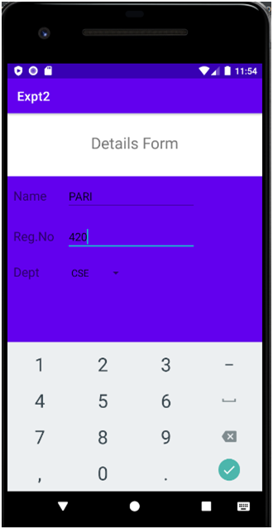

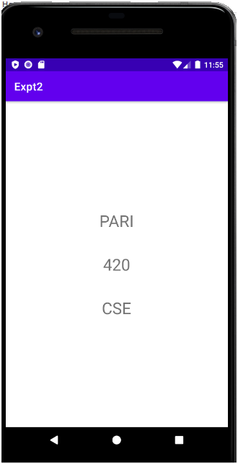

**3. Develop a native calculator application.**

## Aim:

**To develop a Simple Android Application for Native Calculator.**

## Procedure:

### Creating a New project:

* Open Android Studio and then click on File -> New -> New project.
* Then type the Application name as “ex.no.3″ and click Next.
* Then select the Minimum SDK as shown below and click Next.
* Then select the Empty Activity and click Next.
* Finally click Finish.
* It will take some time to build and load the project.

### Designing layout for the Android Application:

* Click on app -> res -> layout -> activity_main.xml.
* Now click on Text as shown below.
* Then delete the code which is there and type the code as given below.

**Activity_main.xml**

**<?xml version="1.0" encoding="utf-8"?>**

**<LinearLayout**

**xmlns:android="http://schemas.android.com/apk/res/android"**

**android:orientation="vertical"**

**android:layout_width="match_parent"**

**android:layout_height="match_parent"**

**android:layout_margin="20dp">**

**<LinearLayout**

**android:id="@+id/linearLayout1"**

**android:layout_width="match_parent"**

**android:layout_height="wrap_content"**

**android:layout_margin="20dp">**

**<EditText**

**android:id="@+id/editText1"**

**android:layout_width="match_parent"**

**android:layout_height="wrap_content"**

**android:layout_weight="1"**

**android:inputType="numberDecimal"**

**android:textSize="20sp" />**

**<EditText**

**android:id="@+id/editText2"**

**android:layout_width="match_parent"**

**android:layout_height="wrap_content"**

**android:layout_weight="1"**

**android:inputType="numberDecimal"**

**android:textSize="20sp" />**

**</LinearLayout>**

**<LinearLayout**

**android:id="@+id/linearLayout2"**

**android:layout_width="match_parent"**

**android:layout_height="wrap_content"**

**android:layout_margin="20dp">**

**<Button**

**android:id="@+id/Add"**

**android:layout_width="match_parent"**

**android:layout_height="wrap_content"**

**android:layout_weight="1"**

**android:text="+"**

**android:textSize="30sp"/>**

**<Button**

**android:id="@+id/Sub"**

**android:layout_width="match_parent"**

**android:layout_height="wrap_content"**

**android:layout_weight="1"**

**android:text="-"**

**android:textSize="30sp"/>**

**<Button**

**android:id="@+id/Mul"**

**android:layout_width="match_parent"**

**android:layout_height="wrap_content"**

**android:layout_weight="1"**

**android:text="*"**

**android:textSize="30sp"/>**

**<Button**

**android:id="@+id/Div"**

**android:layout_width="match_parent"**

**android:layout_height="wrap_content"**

**android:layout_weight="1"**

**android:text="/"**

**android:textSize="30sp"/>**

**</LinearLayout>**

**<TextView**

**android:id="@+id/textView"**

**android:layout_width="match_parent"**

**android:layout_height="wrap_content"**

**android:layout_marginTop="50dp"**

**android:text="Answer is"**

**android:textSize="30sp"**

**android:gravity="center"/>**

**</LinearLayout>**

* Now click on Design and your application will look as given below.
* So now the designing part is completed.

### Java Coding for the Android Application:

* Click on app -> java -> com.example.exno3 -> MainActivity.
* Then delete the code which is there and type the code as given below.

Main_Activity.java

**package com.example.devang.exno3;**

**import android.os.Bundle;**

**import android.support.v7.app.AppCompatActivity;**

**import android.text.TextUtils;**

**import android.view.View;**

**import android.view.View.OnClickListener;**

**import android.widget.Button;**

**import android.widget.EditText;**

**import android.widget.TextView;**

**public class MainActivity extends AppCompatActivity implements OnClickListener**

**{**

**//Defining the Views**

**EditText Num1;**

**EditText Num2;**

**Button Add;**

**Button Sub;**

**Button Mul;**

**Button Div;**

**TextView Result;**

**@Override**

**public void onCreate(Bundle savedInstanceState)**

**{**

**super.onCreate(savedInstanceState);**

**setContentView(R.layout.activity_main);**

**//Referring the Views**

**Num1 = (EditText) findViewById(R.id.editText1);**

**Num2 = (EditText) findViewById(R.id.editText2);**

**Add = (Button) findViewById(R.id.Add);**

**Sub = (Button) findViewById(R.id.Sub);**

**Mul = (Button) findViewById(R.id.Mul);**

**Div = (Button) findViewById(R.id.Div);**

**Result = (TextView) findViewById(R.id.textView);**

**// set a listener**

**Add.setOnClickListener(this);**

**Sub.setOnClickListener(this);**

**Mul.setOnClickListener(this);**

**Div.setOnClickListener(this);**

**}**

**@Override**

**public void onClick (View v)**

**{**

**float num1 = 0;**

**float num2 = 0;**

**float result = 0;**

**String oper = "";**

**// check if the fields are empty**

**if (TextUtils.isEmpty(Num1.getText().toString()) || TextUtils.isEmpty(Num2.getText().toString()))**

**return;**

**// read EditText and fill variables with numbers**

**num1 = Float.parseFloat(Num1.getText().toString());**

**num2 = Float.parseFloat(Num2.getText().toString());**

**// defines the button that has been clicked and performs the corresponding operation**

**// write operation into oper, we will use it later for output**

**switch (v.getId())**

**{**

**case R.id.Add:**

**oper = "+";**

**result = num1 + num2;**

**break;**

**case R.id.Sub:**

**oper = "-";**

**result = num1 - num2;**

**break;**

**case R.id.Mul:**

**oper = "*";**

**result = num1 * num2;**

**break;**

**case R.id.Div:**

**oper = "/";**

**result = num1 / num2;**

**break;**

**default:**

**break;**

**}**

**// form the output line**

**Result.setText(num1 + " " + oper + " " + num2 + " = " + result);**

**}**

**}**

* So now the Coding part is also completed.
* Now run the application to see the output.

## Output:

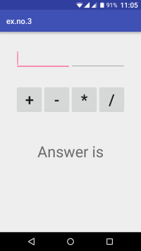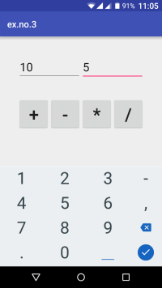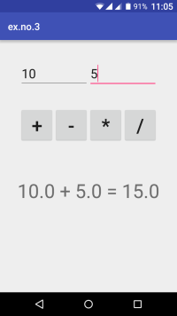

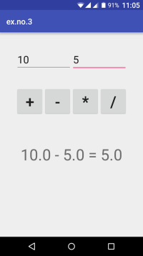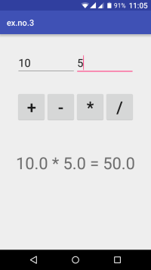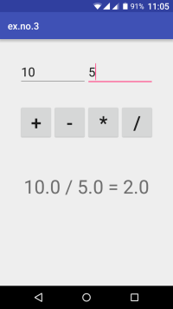

**4. Develop an application that makes use of database.**

### Designing layout for the Android Application:

* **Click on app -> res -> layout -> activity_main.xml.**
* **Now click on Text as shown below.**
* **Then delete the code which is there and type the code as given below.**

**Activity_main.xml**

**<?xml version="1.0" encoding="utf-8"?>**

**<AbsoluteLayout xmlns:android="http://schemas.android.com/apk/res/android"**

**android:layout_width="match_parent"**

**android:layout_height="match_parent">**

**<TextView**

**android:layout_width="wrap_content"**

**android:layout_height="wrap_content"**

**android:layout_x="50dp"**

**android:layout_y="20dp"**

**android:text="Student Details"**

**android:textSize="30sp" />**

**<TextView**

**android:layout_width="wrap_content"**

**android:layout_height="wrap_content"**

**android:layout_x="20dp"**

**android:layout_y="110dp"**

**android:text="Enter Rollno:"**

**android:textSize="20sp" />**

**<EditText**

**android:id="@+id/Rollno"**

**android:layout_width="150dp"**

**android:layout_height="wrap_content"**

**android:layout_x="175dp"**

**android:layout_y="100dp"**

**android:inputType="number"**

**android:textSize="20sp" />**

**<TextView**

**android:layout_width="wrap_content"**

**android:layout_height="wrap_content"**

**android:layout_x="20dp"**

**android:layout_y="160dp"**

**android:text="Enter Name:"**

**android:textSize="20sp" />**

**<EditText**

**android:id="@+id/Name"**

**android:layout_width="150dp"**

**android:layout_height="wrap_content"**

**android:layout_x="175dp"**

**android:layout_y="150dp"**

**android:inputType="text"**

**android:textSize="20sp" />**

**<TextView**

**android:layout_width="wrap_content"**

**android:layout_height="wrap_content"**

**android:layout_x="20dp"**

**android:layout_y="210dp"**

**android:text="Enter Marks:"**

**android:textSize="20sp" />**

**<EditText**

**android:id="@+id/Marks"**

**android:layout_width="150dp"**

**android:layout_height="wrap_content"**

**android:layout_x="175dp"**

**android:layout_y="200dp"**

**android:inputType="number"**

**android:textSize="20sp" />**

**<Button**

**android:id="@+id/Insert"**

**android:layout_width="150dp"**

**android:layout_height="wrap_content"**

**android:layout_x="25dp"**

**android:layout_y="300dp"**

**android:text="Insert"**

**android:textSize="30dp" />**

**<Button**

**android:id="@+id/Delete"**

**android:layout_width="150dp"**

**android:layout_height="wrap_content"**

**android:layout_x="200dp"**

**android:layout_y="300dp"**

**android:text="Delete"**

**android:textSize="30dp" />**

**<Button**

**android:id="@+id/Update"**

**android:layout_width="150dp"**

**android:layout_height="wrap_content"**

**android:layout_x="25dp"**

**android:layout_y="400dp"**

**android:text="Update"**

**android:textSize="30dp" />**

**<Button**

**android:id="@+id/View"**

**android:layout_width="150dp"**

**android:layout_height="wrap_content"**

**android:layout_x="200dp"**

**android:layout_y="400dp"**

**android:text="View"**

**android:textSize="30dp" />**

**<Button**

**android:id="@+id/ViewAll"**

**android:layout_width="200dp"**

**android:layout_height="wrap_content"**

**android:layout_x="100dp"**

**android:layout_y="500dp"**

**android:text="View All"**

**android:textSize="30dp" />**

**</AbsoluteLayout>**

### Java Coding for the Android Application:

* **Click on app -> java -> com.example.exno5 -> MainActivity.**
* **Then delete the code which is there and type the code as given below.**

**Main_activity.java**

**package com.example.exno5;**

**import android.app.Activity;**

**import android.app.AlertDialog.Builder;**

**import android.content.Context;**

**import android.database.Cursor;**

**import android.database.sqlite.SQLiteDatabase;**

**import android.os.Bundle;**

**import android.view.View;**

**import android.view.View.OnClickListener;**

**import android.widget.Button;**

**import android.widget.EditText;**

**public class MainActivity extends Activity implements OnClickListener**

**{**

**EditText Rollno,Name,Marks;**

**Button Insert,Delete,Update,View,ViewAll;**

**SQLiteDatabase db;**

**/** Called when the activity is first created. */**

**@Override**

**public void onCreate(Bundle savedInstanceState)**

**{**

**super.onCreate(savedInstanceState);**

**setContentView(R.layout.activity_main);**

**Rollno=(EditText)findViewById(R.id.Rollno);**

**Name=(EditText)findViewById(R.id.Name);**

**Marks=(EditText)findViewById(R.id.Marks);**

**Insert=(Button)findViewById(R.id.Insert);**

**Delete=(Button)findViewById(R.id.Delete);**

**Update=(Button)findViewById(R.id.Update);**

**View=(Button)findViewById(R.id.View);**

**ViewAll=(Button)findViewById(R.id.ViewAll);**

**Insert.setOnClickListener(this);**

**Delete.setOnClickListener(this);**

**Update.setOnClickListener(this);**

**View.setOnClickListener(this);**

**ViewAll.setOnClickListener(this);**

**// Creating database and table**

**db=openOrCreateDatabase("StudentDB", Context.MODE_PRIVATE, null);**

**db.execSQL("CREATE TABLE IF NOT EXISTS student(rollno VARCHAR,name VARCHAR,marks VARCHAR);");**

**}**

**public void onClick(View view)**

**{**

**// Inserting a record to the Student table**

**if(view==Insert)**

**{**

**// Checking for empty fields**

**if(Rollno.getText().toString().trim().length()==0||**

**Name.getText().toString().trim().length()==0||**

**Marks.getText().toString().trim().length()==0)**

**{**

**showMessage("Error", "Please enter all values");**

**return;**

**}**

**db.execSQL("INSERT INTO student VALUES('"+Rollno.getText()+"','"+Name.getText()+**

**"','"+Marks.getText()+"');");**

**showMessage("Success", "Record added");**

**clearText();**

**}**

**// Deleting a record from the Student table**

**if(view==Delete)**

**{**

**// Checking for empty roll number**

**if(Rollno.getText().toString().trim().length()==0)**

**{**

**showMessage("Error", "Please enter Rollno");**

**return;**

**}**

**Cursor c=db.rawQuery("SELECT * FROM student WHERE rollno='"+Rollno.getText()+"'", null);**

**if(c.moveToFirst())**

**{**

**db.execSQL("DELETE FROM student WHERE rollno='"+Rollno.getText()+"'");**

**showMessage("Success", "Record Deleted");**

**}**

**else**

**{**

**showMessage("Error", "Invalid Rollno");**

**}**

**clearText();**

**}**

**// Updating a record in the Student table**

**if(view==Update)**

**{**

**// Checking for empty roll number**

**if(Rollno.getText().toString().trim().length()==0)**

**{**

**showMessage("Error", "Please enter Rollno");**

**return;**

**}**

**Cursor c=db.rawQuery("SELECT * FROM student WHERE rollno='"+Rollno.getText()+"'", null);**

**if(c.moveToFirst()) {**

**db.execSQL("UPDATE student SET name='" + Name.getText() + "',marks='" + Marks.getText() +**

**"' WHERE rollno='"+Rollno.getText()+"'");**

**showMessage("Success", "Record Modified");**

**}**

**else {**

**showMessage("Error", "Invalid Rollno");**

**}**

**clearText();**

**}**

**// Display a record from the Student table**

**if(view==View)**

**{**

**// Checking for empty roll number**

**if(Rollno.getText().toString().trim().length()==0)**

**{**

**showMessage("Error", "Please enter Rollno");**

**return;**

**}**

**Cursor c=db.rawQuery("SELECT * FROM student WHERE rollno='"+Rollno.getText()+"'", null);**

**if(c.moveToFirst())**

**{**

**Name.setText(c.getString(1));**

**Marks.setText(c.getString(2));**

**}**

**else**

**{**

**showMessage("Error", "Invalid Rollno");**

**clearText();**

**}**

**}**

**// Displaying all the records**

**if(view==ViewAll)**

**{**

**Cursor c=db.rawQuery("SELECT * FROM student", null);**

**if(c.getCount()==0)**

**{**

**showMessage("Error", "No records found");**

**return;**

**}**

**StringBuffer buffer=new StringBuffer();**

**while(c.moveToNext())**

**{**

**buffer.append("Rollno: "+c.getString(0)+"\n");**

**buffer.append("Name: "+c.getString(1)+"\n");**

**buffer.append("Marks: "+c.getString(2)+"\n\n");**

**}**

**showMessage("Student Details", buffer.toString());**

**}**

**}**

**public void showMessage(String title,String message)**

**{**

**Builder builder=new Builder(this);**

**builder.setCancelable(true);**

**builder.setTitle(title);**

**builder.setMessage(message);**

**builder.show();**

**}**

**public void clearText()**

**{**

**Rollno.setText("");**

**Name.setText("");**

**Marks.setText("");**

**Rollno.requestFocus();**

**}**

**}**

**5. Develop an application that makes use of notification.**

## Aim:

**To develop a Android Application that creates an alert upon receiving a message.**

### Creating a New project:

* **Open Android Studio and then click on File -> New -> New project.**

### Creating Second Activity for the Android Application:

* **Click on File -> New -> Activity -> Empty Activity.**
* **Type the Activity Name as SecondActivity and click Finish button.**

Activity_main.xml:

<?xml version="1.0" encoding="utf-8"?>

<LinearLayout xmlns:android="http://schemas.android.com/apk/res/android"

android:layout_width="match_parent"

android:layout_height="match_parent"

android:layout_margin="10dp"

android:orientation="vertical">

<TextView

android:layout_width="wrap_content"

android:layout_height="wrap_content"

android:text="Message"

android:textSize="30sp" />

<EditText

android:id="@+id/editText"

android:layout_width="match_parent"

android:layout_height="wrap_content"

android:singleLine="true"

android:textSize="30sp" />

<Button

android:id="@+id/button"

android:layout_width="wrap_content"

android:layout_height="wrap_content"

android:layout_margin="30dp"

android:layout_gravity="center"

android:text="Notify"

android:textSize="30sp"/>

</LinearLayout>

### Java Coding for the Android Application:

* Click on app -> java -> com.example.exno10 -> MainActivity.

MainActivity.java:

package com.example.exno10;

import android.app.Notification;

import android.app.NotificationManager;

import android.app.PendingIntent;

import android.content.Intent;

import android.os.Bundle;

import android.support.v7.app.AppCompatActivity;

import android.view.View;

import android.widget.Button;

import android.widget.EditText;

public class MainActivity extends AppCompatActivity

{

Button notify;

EditText e;

@Override

protected void onCreate(Bundle savedInstanceState)

{

super.onCreate(savedInstanceState);

setContentView(R.layout.activity_main);

notify= (Button) findViewById(R.id.button);

e= (EditText) findViewById(R.id.editText);

notify.setOnClickListener(new View.OnClickListener()

{

@Override

public void onClick(View v)

{

Intent intent = new Intent(MainActivity.this, SecondActivity.class);

PendingIntent pending = PendingIntent.getActivity(MainActivity.this, 0, intent, 0);

Notification noti = new Notification.Builder(MainActivity.this).setContentTitle("New Message").setContentText(e.getText().toString()).setSmallIcon(R.mipmap.ic_launcher).setContentIntent(pending).build();

NotificationManager manager = (NotificationManager) getSystemService(NOTIFICATION_SERVICE);

noti.flags |= Notification.FLAG_AUTO_CANCEL;

manager.notify(0, noti);

}

});

}

}